SUTD AI / ML Bedmaking Project 🛏️:

## Introduction:

We were tasked with making an AI / ML program to detect whether a hotel bed is made properly.

The factors that decide whether a bed is made properly includes:

1. Is the bed crumpled
2. Are there any stains on the bed
3. Are the things on the bed arranged correctly

The programs we considered in the process includes:

* Label Studio
* Anaconda
* YOLOV5
* OpenCV (for depth camera)

## Steps Taken:

### Step 1: Installation of required python libraries and programs 📚

We installed Label Studio and Anaconda to aid with the labelling and deploying of our dataset.

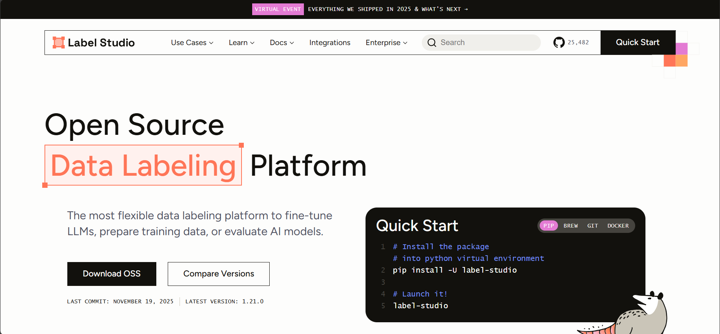

Label Studio - for the processing of images in the dataset and exporting into the YOLO format



Anaconda - for the setup of the Python virtual environment used for running the model

We also need to install the following python libraries to capture the images for our dataset

| $ pip install opencv-python $ pip install ultralytics  $ pip install glob2 |
| --- |

**OpenCV** - for interfacing with the Intel RealSense Camera provided to us

**Ultralytics** - for YOLOv5t

**Glob** - Sorting files

### Step 2: Writing code to collect pictures with depth camera (OpenCV) 📷

Code was written to capture and collect pictures we took of bedsheets using the depth camera:

| import pyrealsense2 as rs import numpy as np import cv2 import yolov5 as yv5 import os import psutil  class TrainingMgr:  def __init__(self):  self.counter = 0   pass   def collect_data(self, image_data, crumpled):  crumpled_status = "error"  if crumpled:  crumpled_status = "crumpled"  else:  crumpled_status = "uncrumpled"   filename = f"{str(self.counter)}_{crumpled_status}.png"  output_path = os.path.join("data", filename)  cv2.imwrite(output_path, image_data)  print(f"Saved as {filename}")  self.counter += 1  pass   def get_memory_usage(self):  process = psutil.Process()  mem = process.memory_info().rss *# in bytes*  print(f"Memory usage: {mem / 1024**2:.2f} MB")  pass   class Resolution:  def __init__(self, x, y):  self.x = x  self.y = y  class CameraSettings:  def __init__(self, resolution, framerate):  self.resolution = resolution  self.framerate = framerate  class Camera:  def __init__(self, camera_settings, screenshot_crumpled_key, screenshot_uncrumpled_key, training_mgr):  self.camera_settings = camera_settings  self.screenshot_crumpled_key = screenshot_crumpled_key  self.screenshot_uncrumpled_key = screenshot_uncrumpled_key  self.training_mgr = training_mgr   self.pipeline = rs.pipeline()  self.config = rs.config()  self.config.enable_stream(rs.stream.color, self.camera_settings.resolution.x, self.camera_settings.resolution.y, rs.format.bgr8, 5)  self.profile = self.pipeline.start(self.config)  self.align = rs.align(rs.stream.color)   def camera_process(self):  try:  while True:  frames = self.pipeline.wait_for_frames()  aligned_frames = self.align.process(frames)   color_frame = aligned_frames.get_color_frame()   if not color_frame:  continue   color_image = np.asanyarray(color_frame.get_data())    cv2.imshow("Image", color_image)   key = cv2.waitKey(1)  if key == 27: *# ESC to exit*  break   if key == self.screenshot_crumpled_key:  print("Taken photo | Crumpled")  self.training_mgr.collect_data(color_image, True)     elif key == self.screenshot_uncrumpled_key:  print("Taken photo | Uncrumpled")  self.training_mgr.collect_data(color_image, False)   elif key == 77:  print("Getting Memory")  self.training_mgr.get_memory_usage()    finally:  self.pipeline.stop()  cv2.destroyAllWindows()    def main():  training_mgr = TrainingMgr()  res = Resolution(1280, 720)  camera_settings = CameraSettings(resolution=res, framerate=30)    *# 1 - crumpled, 2 - uncrumpled*  camera = Camera(camera_settings, screenshot_crumpled_key=49, screenshot_uncrumpled_key=50, training_mgr=training_mgr)    camera.camera_process() *# Starts camera process loop*  pass  if __name__ == "__main__":  main() |
| --- |

This code was used to capture images of the bedsheet we had in our working space:

Side View:

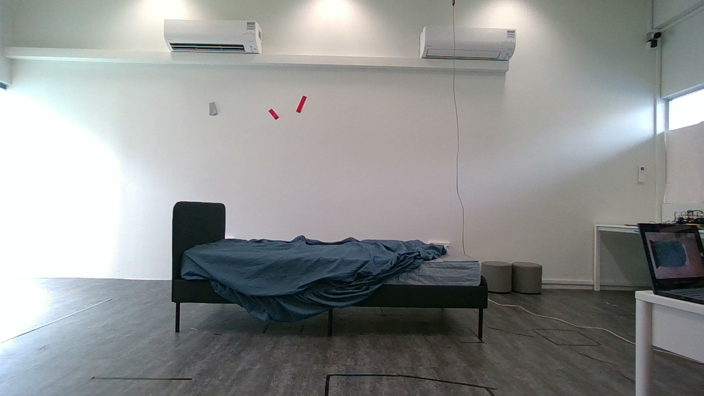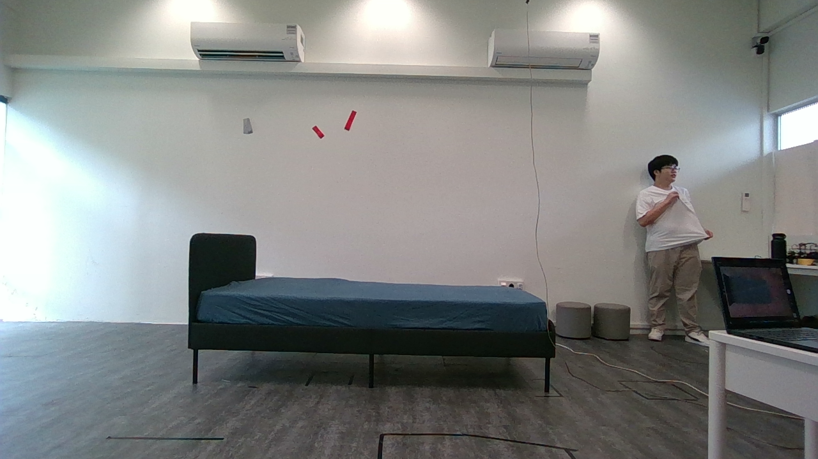

Top View:

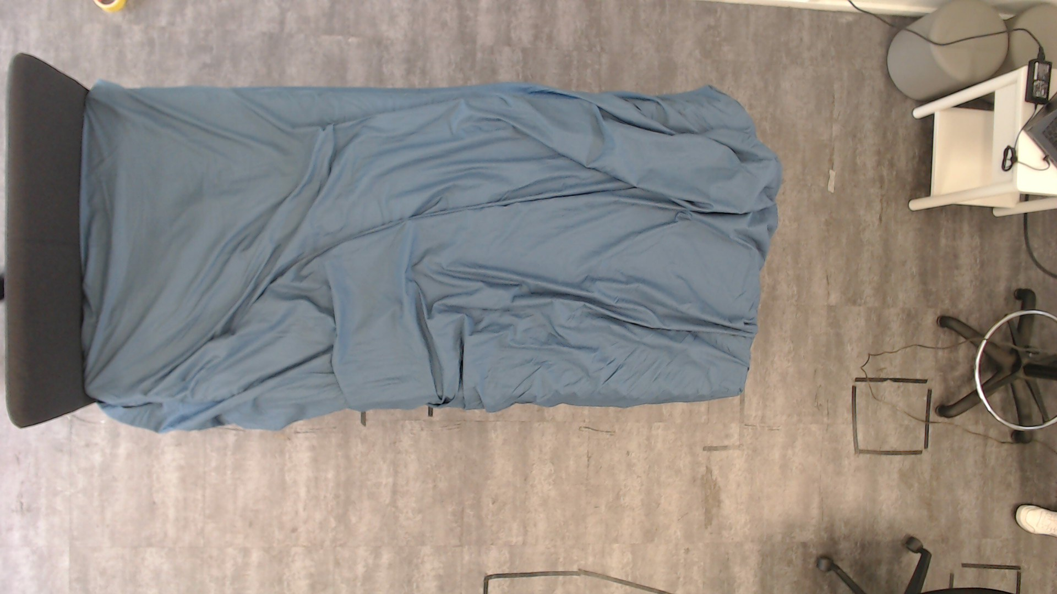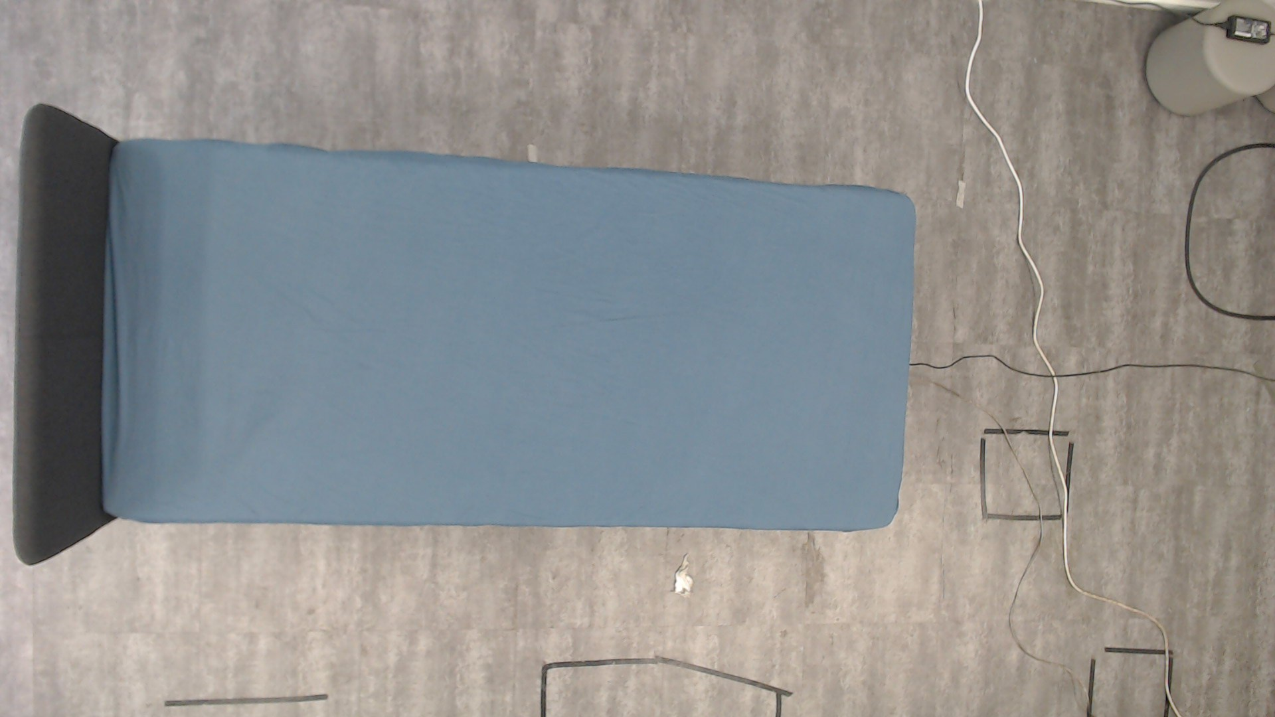

Approximately 1,200 pictures were captured with this program.

The top view was manually taken on a Logitech webcam using the Windows Camera program.

### 

### Step 3: Writing code to filter and sort pictures 🖼️

By writing code to partially automate the sorting, we saved time by pressing 1 or 2 on our keyboard to identify the crumpled and uncrumpled beds.

| import cv2 import os import glob   def filter_and_classify_images():  *# Get list of filenames starting with 'WIN'*  win_files = (  glob.glob("Bed Photo/WIN*.jpg")  + glob.glob("Bed Photo/WIN*.jpeg")  + glob.glob("Bed Photo/WIN*.png")  )   if not win_files:  print("No files found starting with 'WIN'")  return   print(f"Found {len(win_files)} files starting with 'WIN'")   *# Counter for numbering*  count = 1   for filename in win_files:  *# Read the image*  img = cv2.imread(filename)   if img is None:  print(f"Could not open image: {filename}")  continue   *# Display image*  cv2.imshow("Image Classification", img)  print(f"Image: {filename}")  print("Press '1' for crumpled, '2' for uncrumpled, 'q' to quit")   *# Wait for key press*  while True:  key = cv2.waitKey(0) & 0xFF   if key == ord("1"): *# Crumpled*  crumple_status = "crumpled2"  break  elif key == ord("2"): *# Uncrumpled*  crumple_status = "uncrumpled2"  break  elif key == ord("q"): *# Quit*  cv2.destroyAllWindows()  print("Classification cancelled by user")  return  else:  print(  "Invalid key! Press '1' for crumpled, '2' for uncrumpled, 'q' to quit"  )   *# Create new filename*  name, ext = os.path.splitext(filename)  new_filename = f"top_{count}_{crumple_status}{ext}"   *# Rename the file*  try:  os.rename(filename, new_filename)  print(f"Renamed: {filename} -> {new_filename}")  count += 1  except OSError as e:  print(f"Error renaming file {filename}: {e}")   cv2.destroyAllWindows()  print("Classification completed!")   if __name__ == "__main__":  filter_and_classify_images() |
| --- |

### Step 4: Labelling of our dataset on Label Studio 🏷️

Label Studio was used to crop out the bed in each image and allowed us to label each bed with either crumpled or uncrumpled tags.

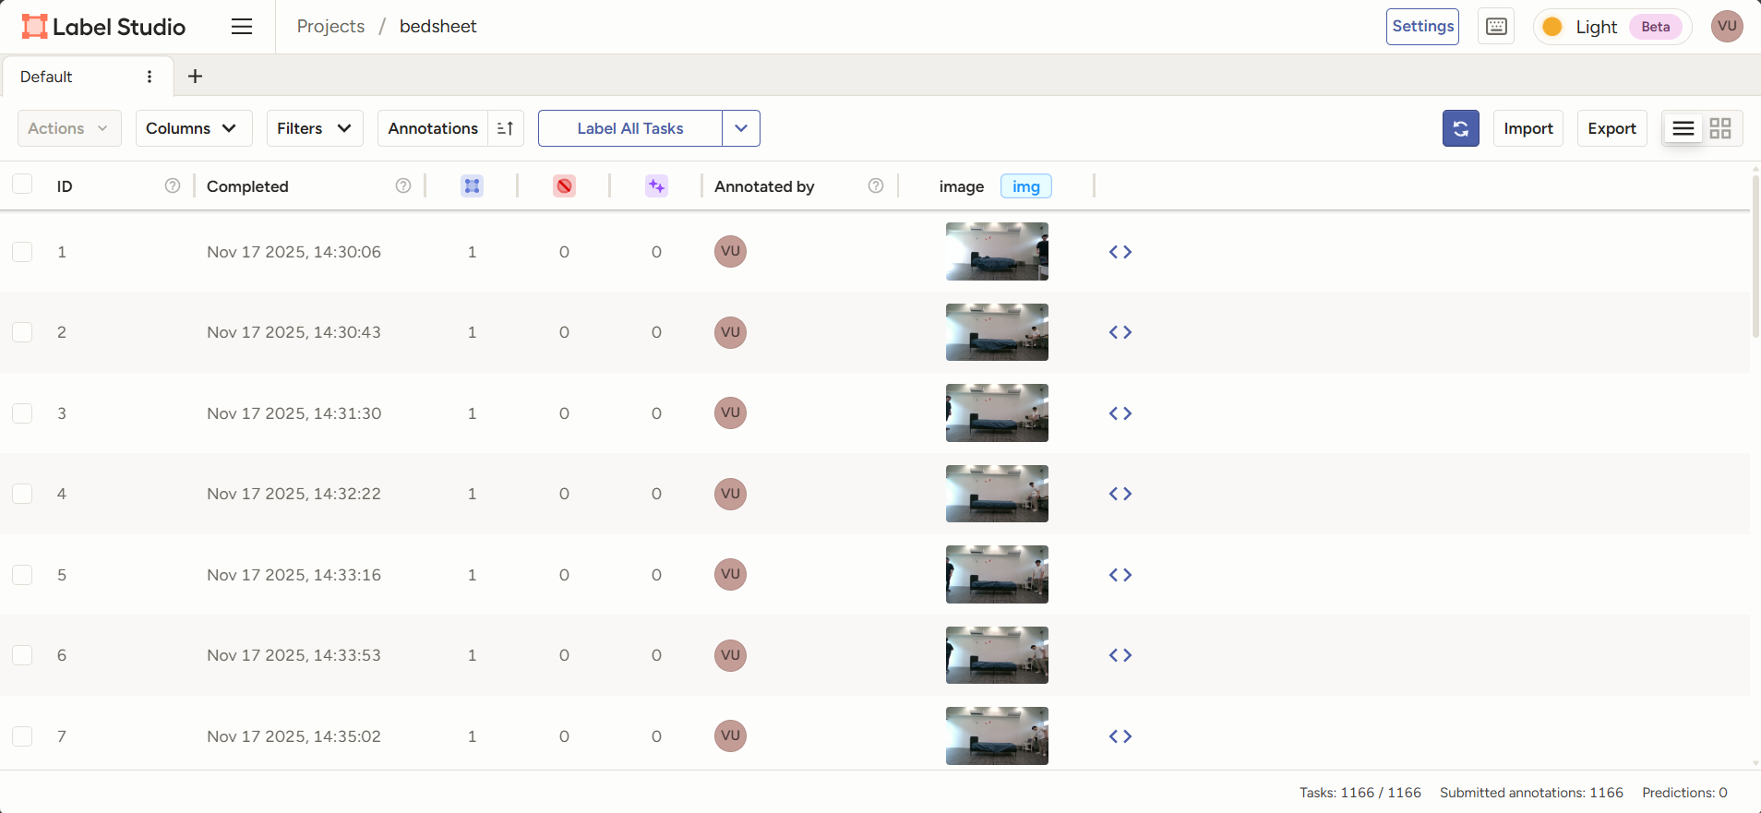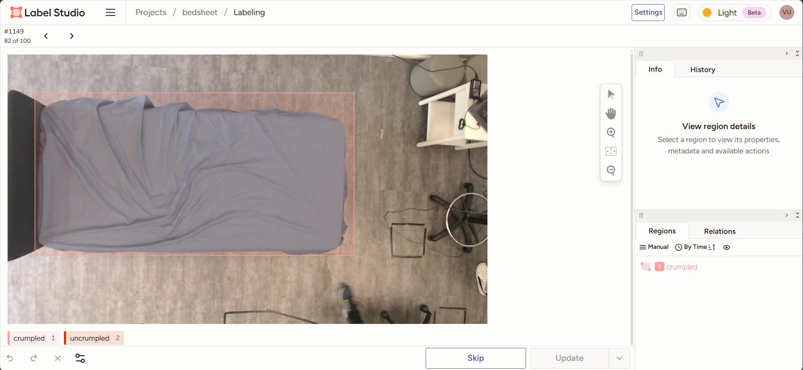

The process of cropping and labelling all the images was fairly arduous, as attempts to use [models to automate the cropping process](https://github.com/HumanSignal/label-studio-ml-backend?tab=readme-ov-file#quickstart) were futile (and also not worth the effort of debugging).

### 

### Step 5: Searching the Internet for additional datasets 📊

Since we were not able to create datasets for stained beds, we searched online for existing ones:

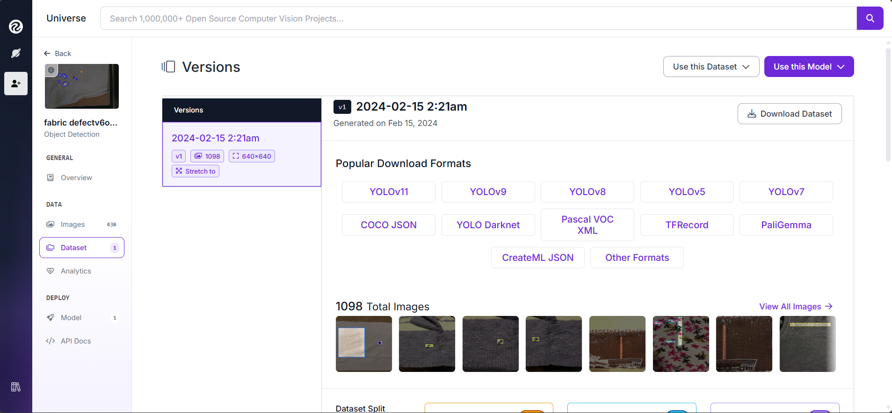

[Dataset of stained sheets found online](https://universe.roboflow.com/sant-anna/fabric-defectv6obb/dataset/1)

Stock images of crumpled and uncrumpled bedsheets of different patterns and colours were also labelled and added to our dataset:

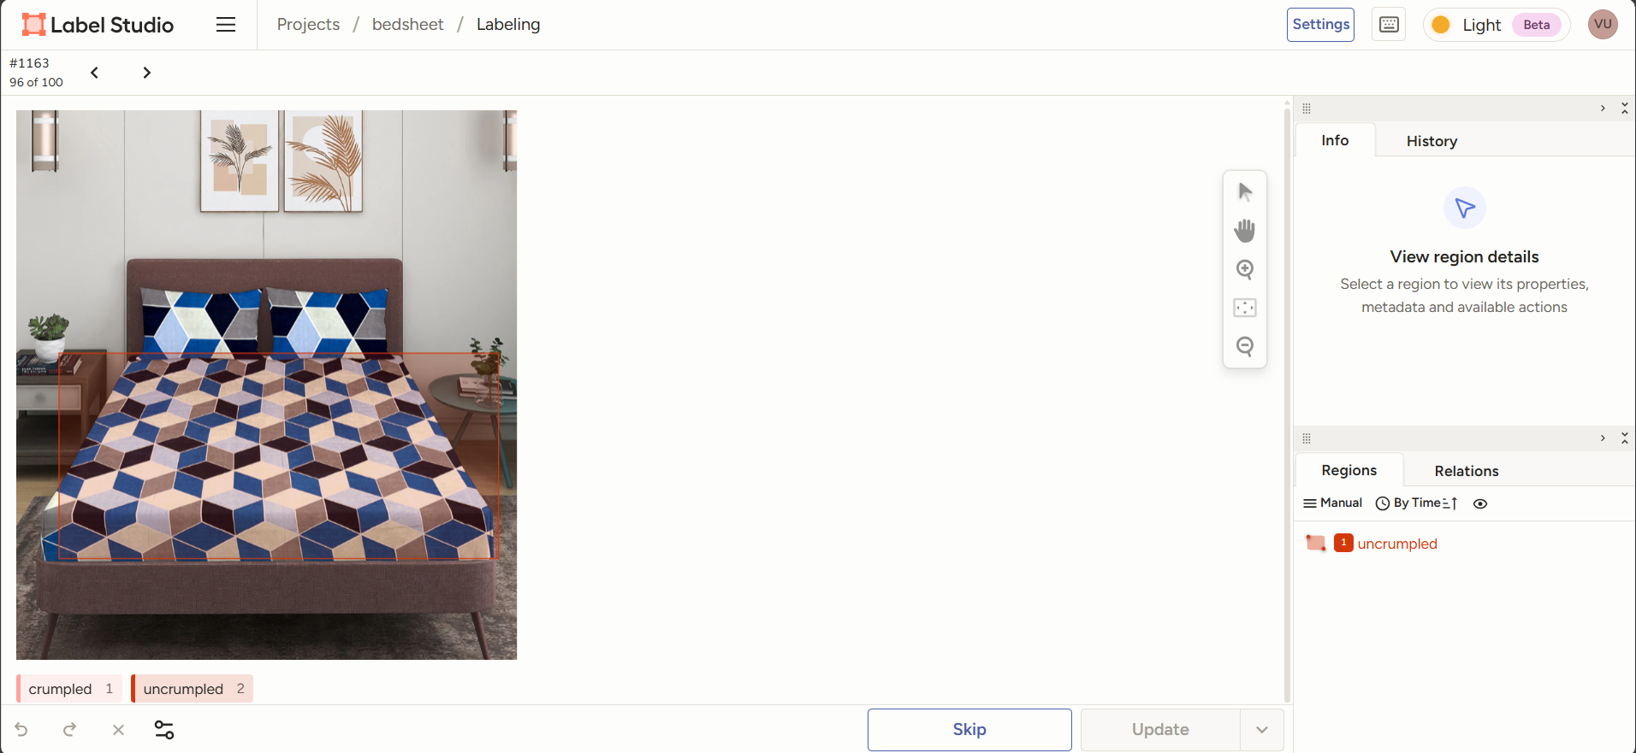

### Step 6: Training of models for bed stains and crumple using Google Colab 🤖

For this part, we referred to a [Google Colab notebook](https://colab.research.google.com/github/EdjeElectronics/Train-and-Deploy-YOLO-Models/blob/main/Train_YOLO_Models.ipynb?authuser=1#scrollTo=gzaJQ2sGEPhP) shared online to help us train our model.

| $ yolo detect train data=/content/data.yaml model=yolov8m.pt epochs=100 imgsz=640 |
| --- |

We used epochs=100 to ensure that the model is accurate during testing.

This is the output for the bed crumple model:

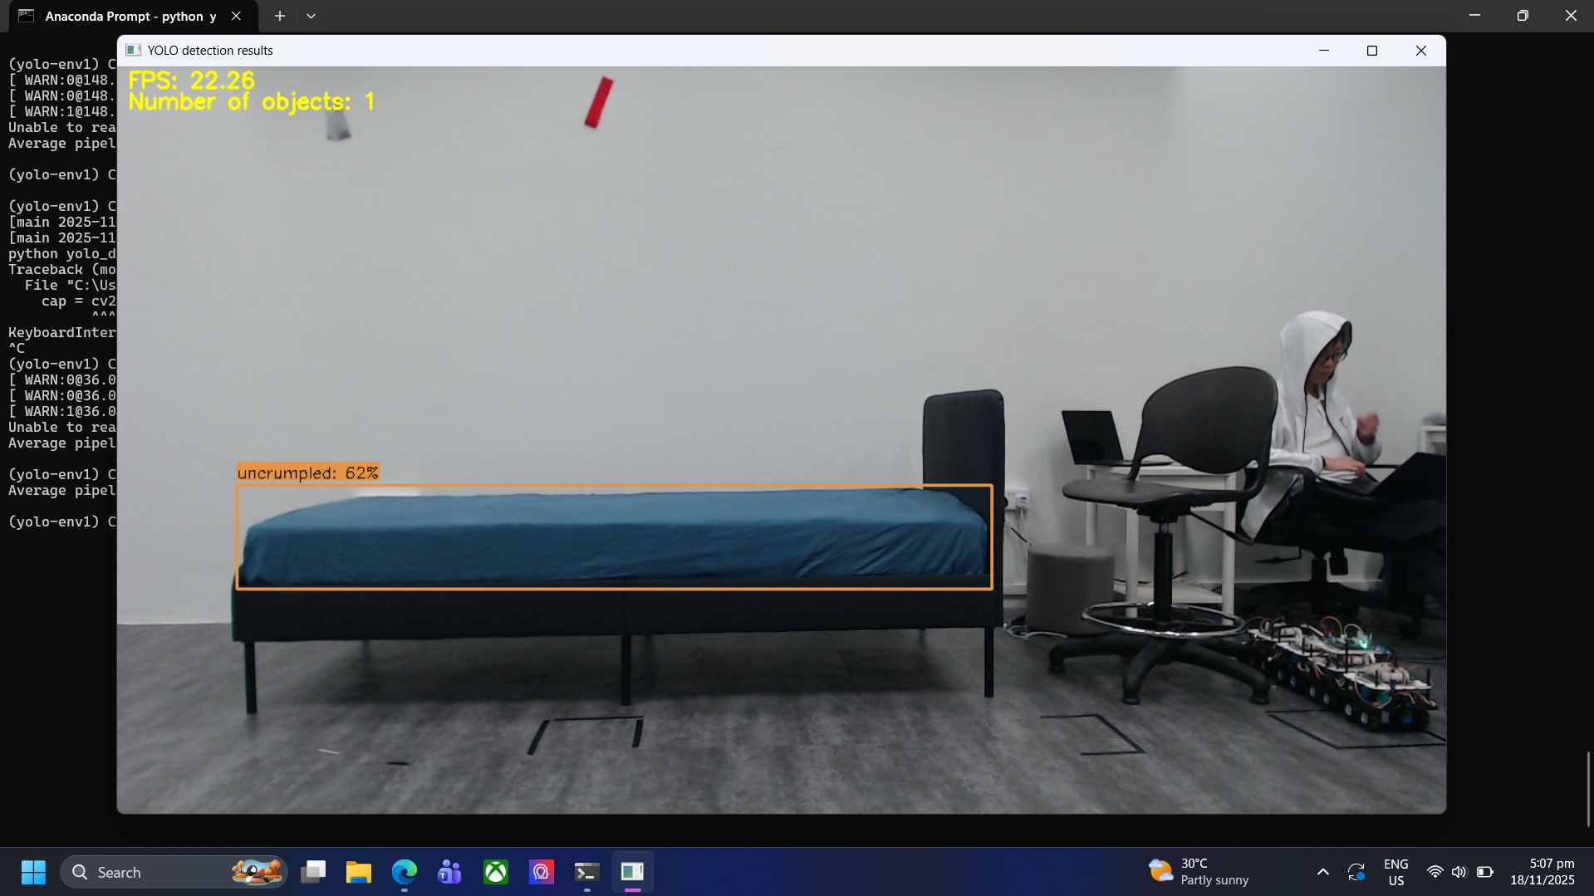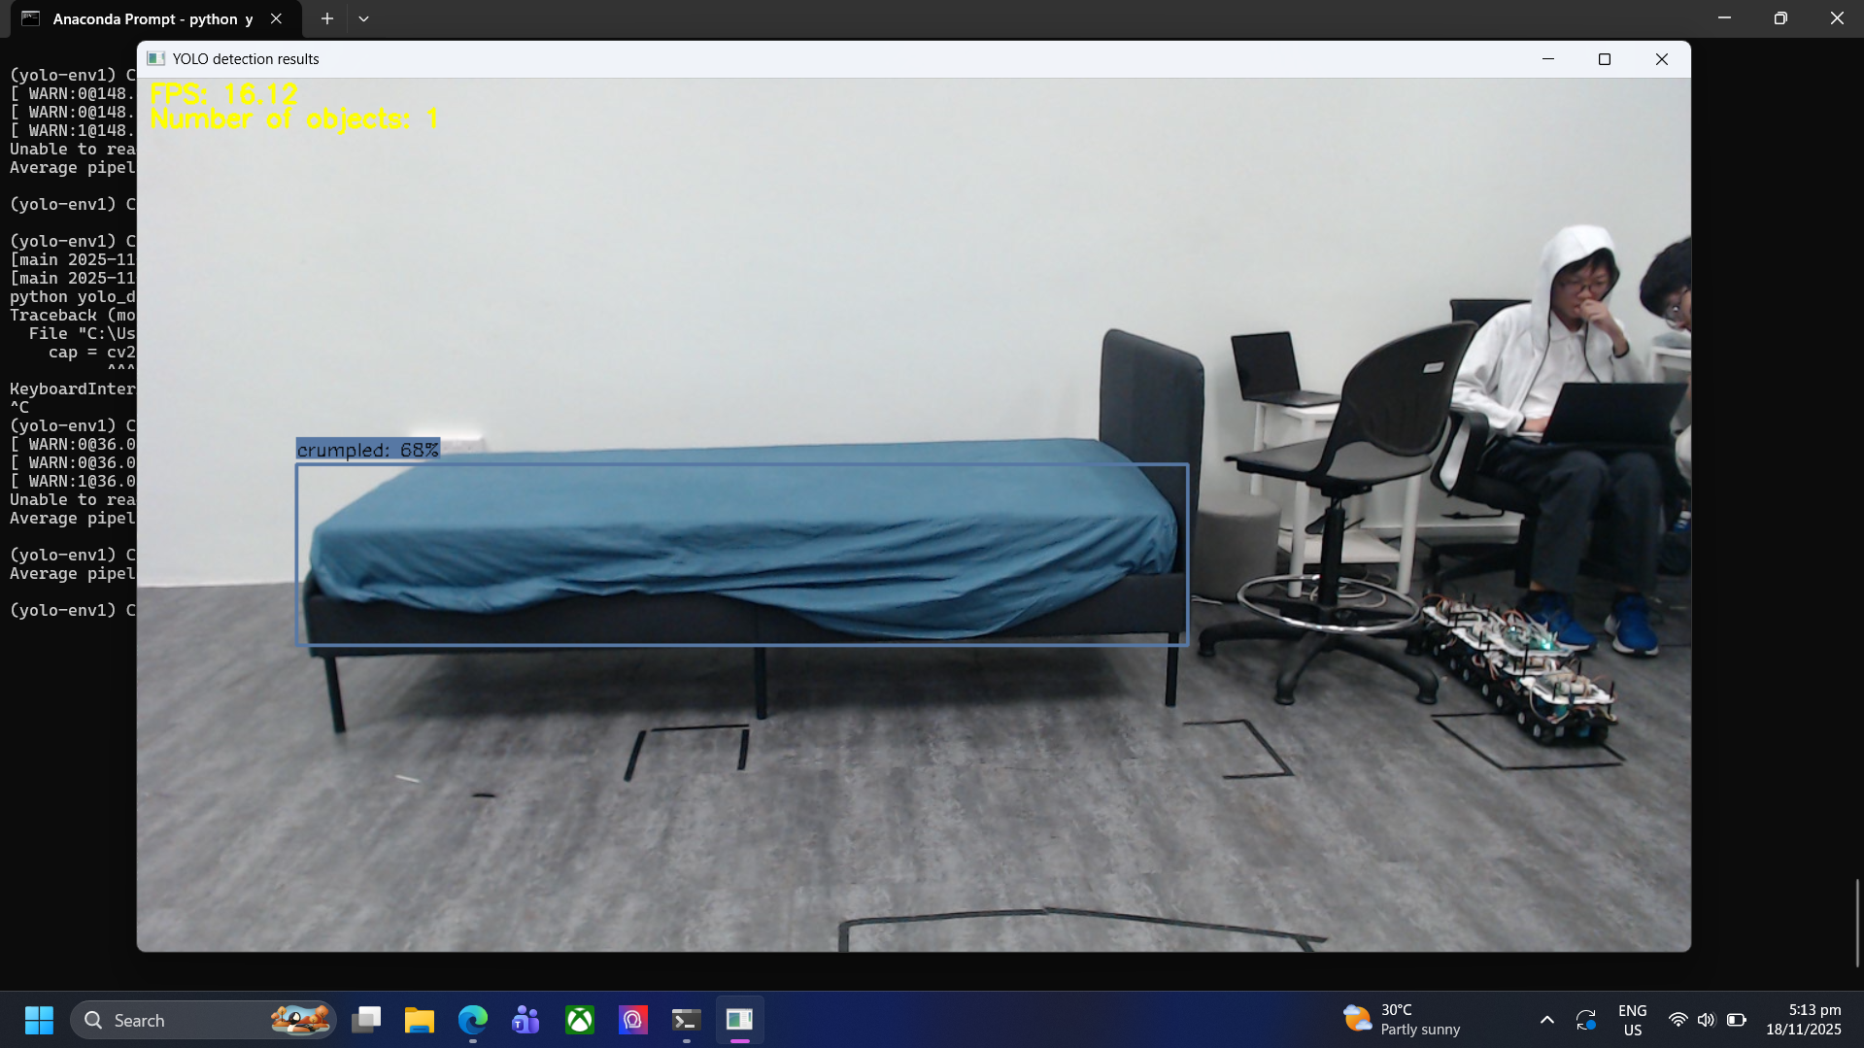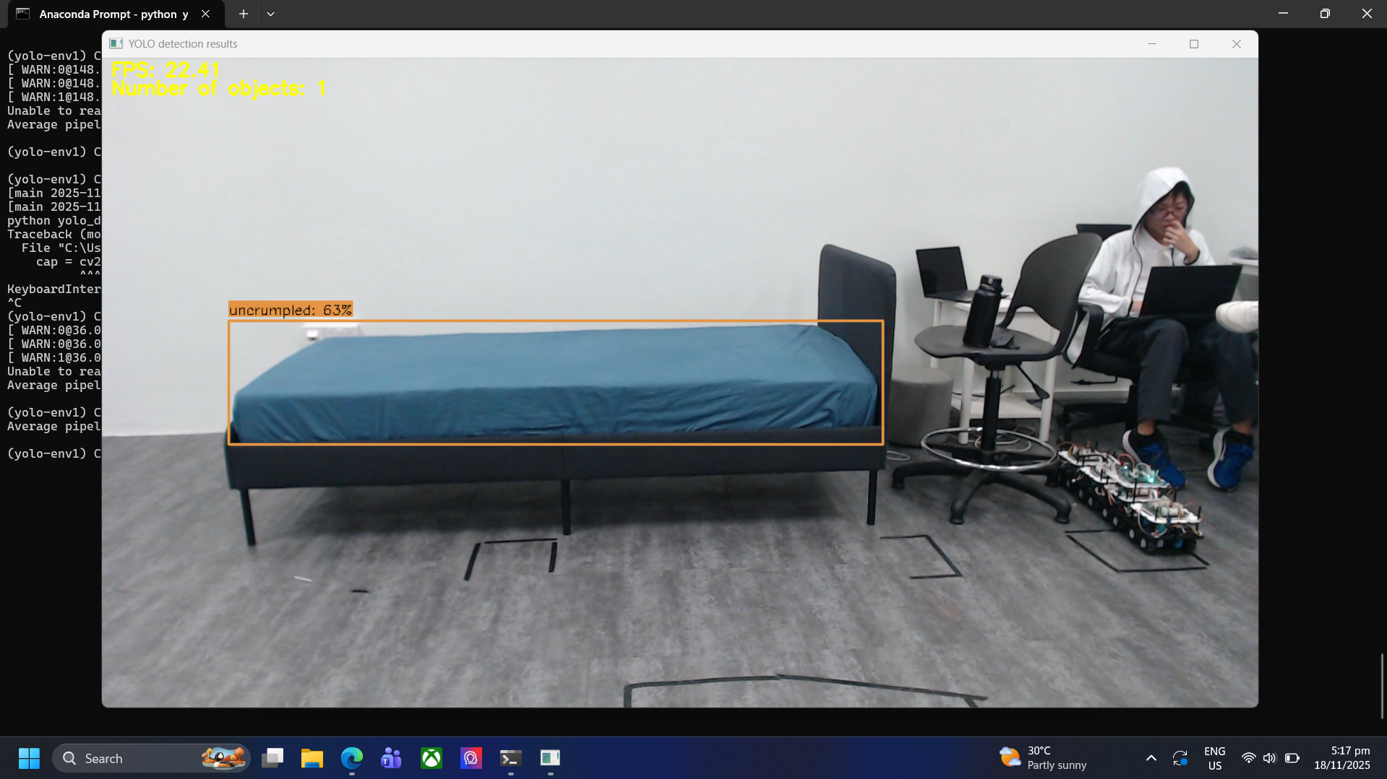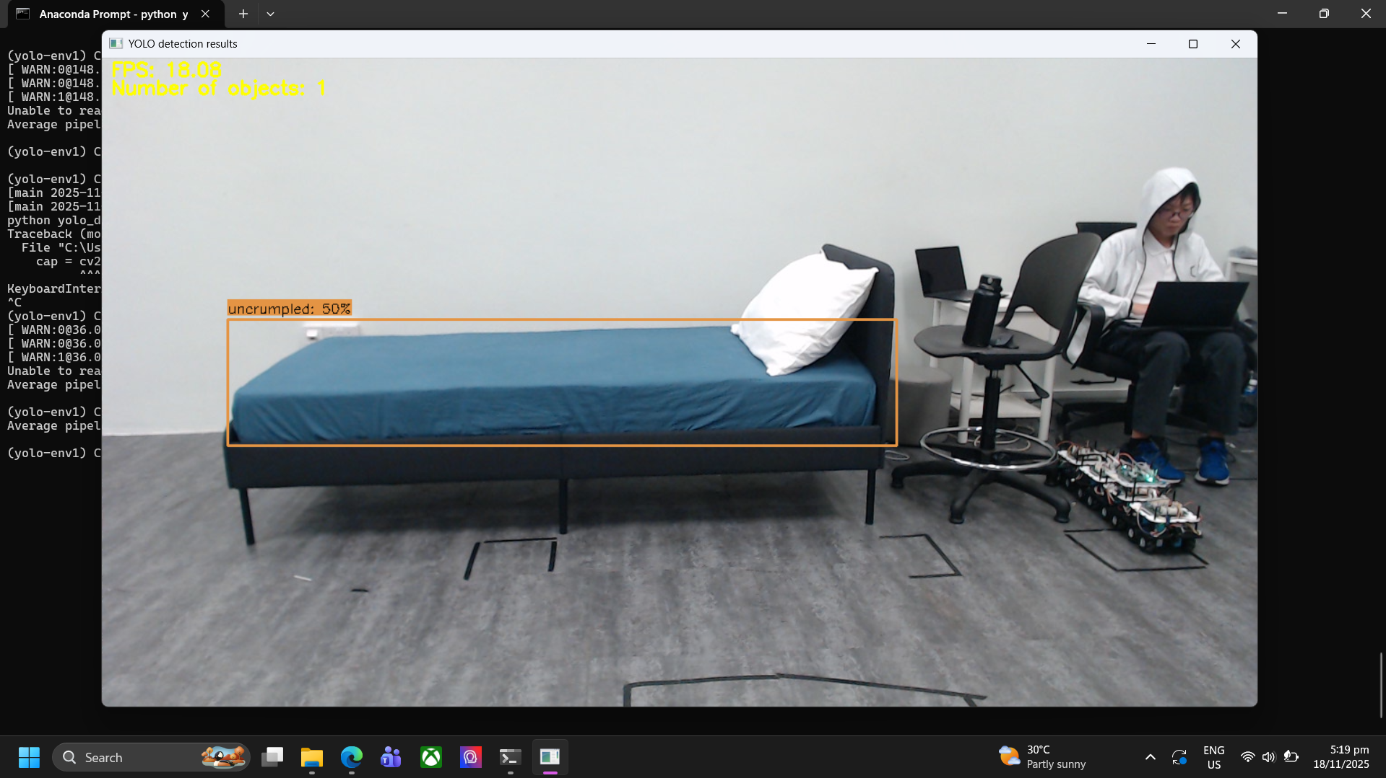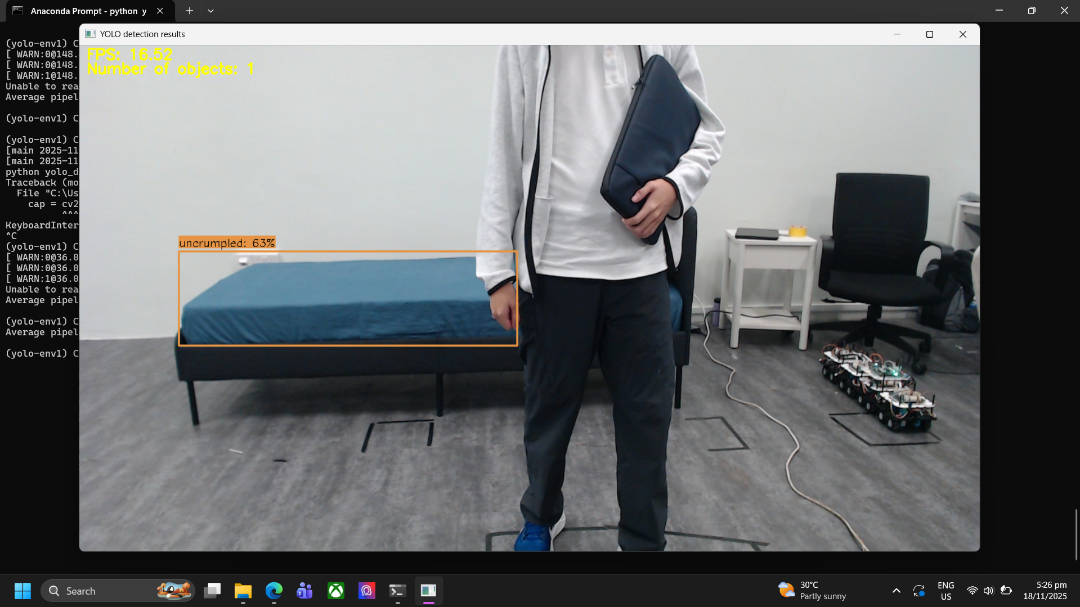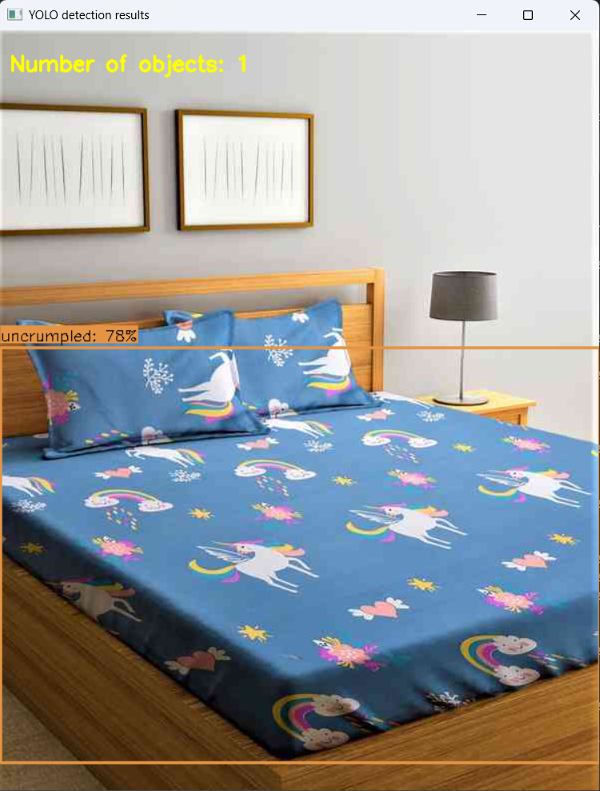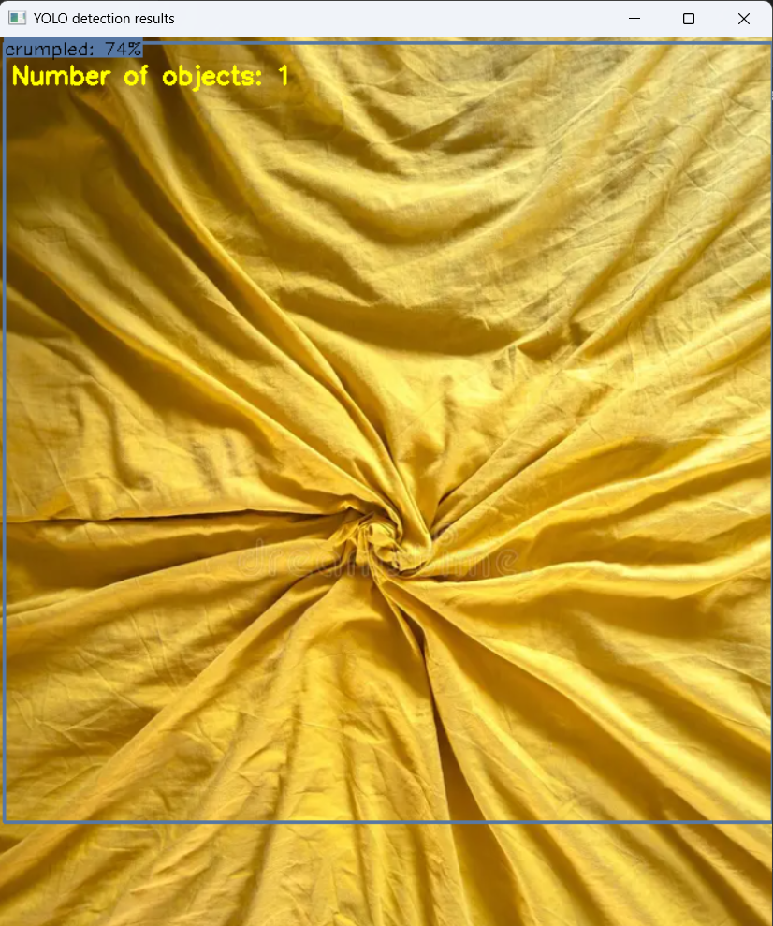

Each model took about 1 hour to fully train on Google Colab.

### Step 7: Using pre-trained model online for bed detection using YOLOV8 and our trained models on bedsheet to draw bounding boxes 🤖

By using the preexisting [yolov8.pt](http://yolov8.pt) model provided by YOLO we can do object detection to figure out the bounding box of the bed

Code for detecting bed:

| from ultralytics import YOLO from statistics import median import cv2 import torch   my_model = YOLO("/content/my_model/yolov8.pt")  results = my_model("bed.jpeg", save=True)    for r in results:  boxes = r.boxes  names = r.names   for box in boxes:  x1, y1, x2, y2 = box.xyxy.int().tolist()[0]  class_id = int(box.cls)  confidence = float(box.conf)  class_name = names[class_id]  print(f"Object: {class_name}, Coordinates: ({x1}, {y1}, {x2}, {y2}), Confidence: {confidence:.2f}") |
| --- |

Code for detecting stains:

| from ultralytics import YOLO from statistics import median import cv2 import torch  my_model = YOLO("/content/my_model/my_model.pt") *# TODO: Path to trained model* results = my_model("stained_bed2.jpeg", save=True) *# TODO: Path to test image*  for r in results:  boxes = r.boxes  names = r.names   for box in boxes:  x1, y1, x2, y2 = box.xyxy.int().tolist()[0]  class_id = int(box.cls)  confidence = float(box.conf)  class_name = names[class_id]  print(f"Object: {class_name}, Coordinates: ({x1}, {y1}, {x2}, {y2}), Confidence: {confidence:.2f}") |
| --- |

The same code was repeated for the process of identifying the crumpleness of the bed with the model trained for crumpleness.

### Step 8a: Writing a final program to detect all aspects of the bedmaking process 🏁

| from ultralytics import YOLO from statistics import median import cv2 import torch  crumple_model = YOLO("crumple.pt") stain_model = YOLO("stain.pt") bed_model = YOLO("yolov8m.pt")  image_path = "test_img_1.jpg"  crumple_results = crumple_model(image_path, save=True) stain_results = stain_model(image_path, save=True) bed_results = bed_model(image_path, save=True)  results = [crumple_results, stain_results, bed_results]  *# detection_results: [Bed present, Crumple present, Stain present]* detection_results = [False, False, False]  stain_list = [  "broken-end", "coffee-stain", "double-ends", "double-picks", "hole",   "ink-stain", "kn", "knot", "missing-picks", "oil-stain", "pin-marks",   "slip-knot", "stain", "thread-out", "tiny-hole" ]  bed_box = {"x1": None, "y1": None, "x2": None, "y2": None}   stain_boxes = [] crumple_detected = False  for result in results:  for r in result:  boxes = r.boxes  names = r.names   for box in boxes:  x1, y1, x2, y2 = box.xyxy.int().tolist()[0]  class_id = int(box.cls)  confidence = float(box.conf)  class_name = names[class_id].lower()   print(f"Object: {class_name}, Coordinates: ({x1}, {y1}, {x2}, {y2}), Confidence: {confidence:.2f}")   *# Bed detected*  if class_name == "bed":  detection_results[0] = True  bed_box = {"x1": x1, "y1": y1, "x2": x2, "y2": y2}   *# Crumple detected*  elif class_name == "crumpled":  crumple_detected = True   *# Save stain boxes for later checking*  elif class_name in stain_list:  stain_boxes.append((x1, y1, x2, y2))  def is_inside(inner, outer):  """Return True if inner box lies fully inside outer box."""  ix1, iy1, ix2, iy2 = inner  ox1, oy1, ox2, oy2 = outer  return ix1 >= ox1 and iy1 >= oy1 and ix2 <= ox2 and iy2 <= oy2  if detection_results[0]:  for sbox in stain_boxes:  if is_inside(sbox, (bed_box["x1"], bed_box["y1"], bed_box["x2"], bed_box["y2"])):  detection_results[2] = True  break   detection_results[1] = crumple_detected  print("Final detection results:", detection_results)  bed_ready_status = False  if (detection_results[0] and (not detection_results[1]) and (not detection_results[1])):  bed_ready_status = True  print(f"Bed Ready Status {bed_ready_status}") |
| --- |

The code decides that if either crumpleness or stains or both are detected the bed is not ready

Note that this code requires an image of the bed rather than a live feed.

### Step 8b: Improving the model by adding more factors to determine how well the hotel bed is made

We repeated the same training process for the detection of the position and alignment of the pillow and blanket on the bed

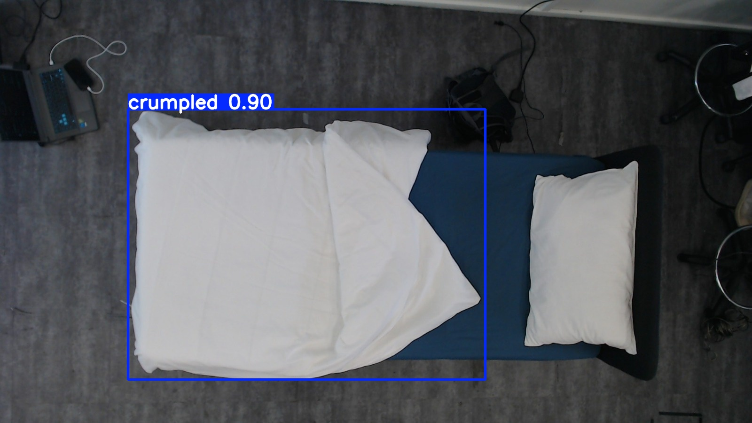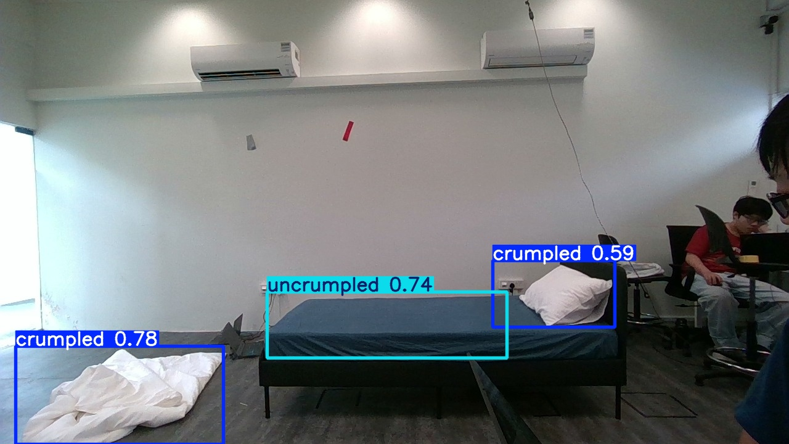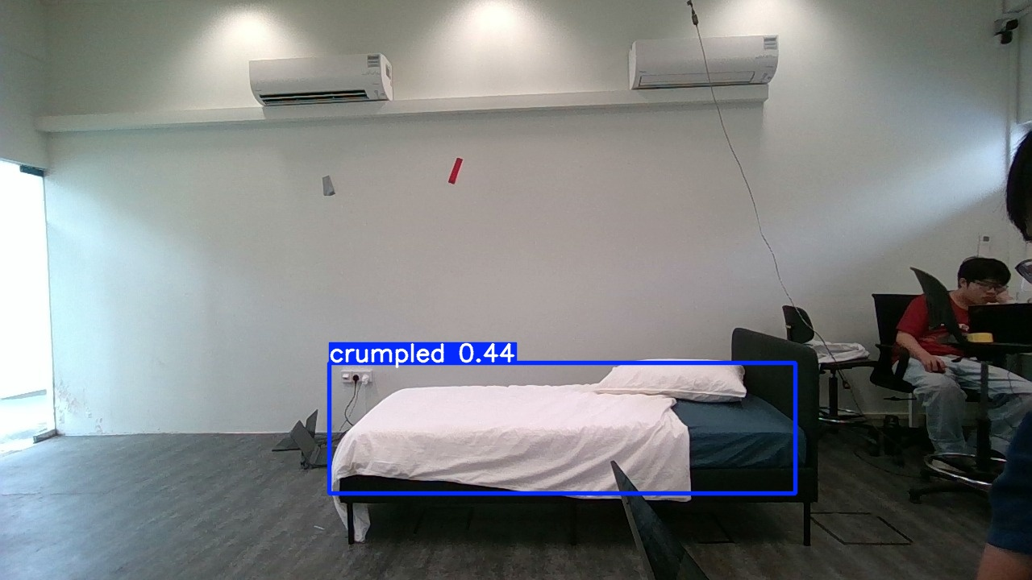

Now we just need to replace the final crumple model file with a new model that also detects the crumpleness of the blanket and alignment of the pillow.

### Resources Used 🌐:

**Label Studio:**

[Open Source Data Labeling | Label Studio](https://labelstud.io/)

**YOLO Model Training:**

[Train_YOLO_Models.ipynb - Colab](https://colab.research.google.com/github/EdjeElectronics/Train-and-Deploy-YOLO-Models/blob/main/Train_YOLO_Models.ipynb?authuser=1#scrollTo=gzaJQ2sGEPhP)

**Anaconda:**

[Advance AI with Open Source | Anaconda](https://www.anaconda.com/)\

LICENSE

Bedmaking detection model

Copyright (C) 2025-2150 Hoe Zheng Yong, Angus Chua Zi Meng, Vuitton Teo Huai Ming

Bedmaking detection model is free software; You can redistribute it and/or modify it under the terms of:

- the GNU Affero General Public License version 3 as published by the Free Software Foundation.

You don't have to do anything special to accept the license and you don’t have to notify anyone which that you have made that decision.

Bedmaking detection model is distributed in the hope that it will be useful, but WITHOUT ANY WARRANTY;

without even the implied warranty of MERCHANTABILITY or FITNESS FOR A PARTICULAR PURPOSE.

See your chosen license for more details.

You should have received a copy of both licenses along with Bedmaking detection model.

If not, see <http://www.gnu.org/licenses/>.

There is a strong belief within us that the license we have chosen provides not only the best solution for providing you with the essential freedom necessary to use Bedmaking detection model within your projects, but also for maintaining enough copyleft strength for us to feel confident and secure with releasing our hard work to the public. For your convenience we've included our own interpretation of the license we chose, which can be seen below.

Our interpretation of the GNU Affero General Public License version 3: (Quoted words are words in which there exists a definition within the license to avoid ambiguity.)

1. You must always provide the source code, copyright and license information of Bedmaking detection model whenever you "convey" any part of Bedmaking detection model;

be it a verbatim copy or a modified copy.

2. Bedmaking detection model was developed as a library and has therefore been designed without knowledge of your work; as such the following should be implied:

a) Bedmaking detection model was developed without knowledge of your work; as such the following should be implied:

i) Bedmaking detection model should not fall under a work which is "based on" your work.

ii) You should be free to use Bedmaking detection model in a work covered by the:

- GNU General Public License version 2

- GNU Lesser General Public License version 2.1

This is due to those licenses classifying Bedmaking detection model as a work which would fall under an "aggregate" work by their terms and definitions;

as such it should not be covered by their terms and conditions. The relevant passages start at:

- Line 129 of the GNU General Public License version 2

- Line 206 of the GNU Lesser General Public License version 2.1

b) If you have not "modified", "adapted" or "extended" Bedmaking detection model then your work should not be bound by this license,

as you are using Bedmaking detection model under the definition of an "aggregate" work.

c) If you have "modified", "adapted" or "extended" Bedmaking detection model then any of those modifications/extensions/adaptations which you have made

should indeed be bound by this license, as you are using Bedmaking detection model under the definition of a "based on" work.

Our hopes is that our own interpretation of license aligns perfectly with your own values and goals for using our work freely and securely. If you have any questions at all about the licensing chosen for Bedmaking detection model you can email us directly at <project support email> or you can get in touch with the license authors (the Free Software Foundation) at licensing@fsf.org to gain their opinion too.

Alternatively you can provide feedback and acquire the support you need at our support forum. We'll definitely try and help you as soon as possible, and to the best of our ability; as we understand that user experience is everything, so we want to make you as happy as possible! So feel free to get in touch via our support forum and chat with other users of Bedmaking detection model here at:

<project support link> or email zhengyonghoe@gmail.com, milliunati8@gmail.com

Thanks, and we hope you enjoy using Bedmaking detection model and that it's everything you ever hoped it could be.